A Brief Reflection On The History Of The Yucatán:
An inquiry into the religious nature of Mayan Astronomy

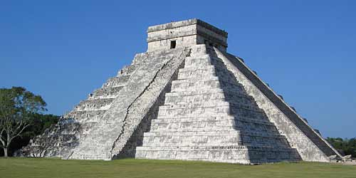
The sun rises in okni (east) and sets in elni (west). The return of the sun to the underworld marks the beginning of the new day. Just as the Maya people were created in darkness before the sun god and moon goddess were wed, so too are all things created; in darkness (Watanabe). Their cosmogony was understood to have been founded in the Fourth Creation (we’re now in the Fifth Creation). They were made from corn, or more appropriately, maize. The Maya were a very mathematically-advanced and a meticulously-detailed people. They tracked the cycle of the sun’s path in the sky. They paid particular attention to lunar cycles with a schematic lunar table, of their own creation, which acted as a prediction apparatus for lunar eclipses. It was necessary for them to track the heliacal appearance of the Moon and across the sky; they thought that solar eclipses were perilous events. The Maya held that a solar eclipse was accompanied by glyphs of death, crop failure, and by sky-supporting deities apparently thought to descend to Earth to wreck havoc on their people. The Maya wanted to predict these eclipses that the threatened disasters upon such an incidence might be evaded with religious ceremonial [sacrifices]. Maya cosmology and astronomy was inextricably linked to religion (Thompson).
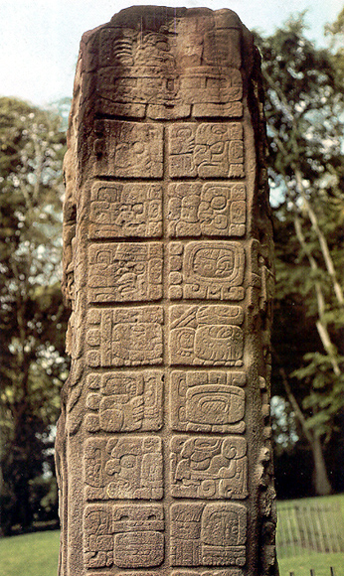
Many centers and observatories, such as that in Chichén-Itzá in the Yucatán Peninsula located in Southeastern Mexico (See Figure 1), have temples that were built to study the rotational paths of Venus, the Sun, and the Moon (Fuson). The Castillo or “Temple of Kukulcan” (Quetzalcóatl), the feathered serpent and the god of civilization and knowledge, is located in Chichén Itzá. It was probably built around A.D. 1050 during the late Mayan Period. It has four stairways, each of which has 91 steps, and a platform on top, making a total of 365 steps; the exact number of days in a Civil calendar year (Fuson). From their observations of the cycle of Venus, the Maya came up with the “sacred year” which had a 260-day long cycle. Venus (also called “Noh Ek,” which means “great star,” or “Xux Ek,” which means “wasp star”) was the “Evening Star” for 250 days, and then disappeared for 8 days. When it rose again, it became the “Morning Star.” This full cycle, referred to as the “sacred year,” is very close to the 260-day “divine year” (Thompson). The “Mayan passion for time,” as it is called, is more notable and better appreciated by observing their many stone “stelae,” which now stand as records of early mathematical equations of sidereal cycles and allude to a three-count calendar that the Maya used (See Figure 2).
(Figure 1: Temple of Kukulcan in Chichén Itzá)
The cardinal directions (north, south, east, and west) were not used by the Maya. Instead, they referred to the place where the sun entered the sky as “okni.” The place where the sun started its way to the underworld (where it sets) was referred to as “elni.” Modern translations of “north” and “south” primarily refer to the notions of “up” or “down,” and do not refer to specific static directions (Watanabe). To the Maya people, there was no abstract title for direction extrinsic of the movement of celestial bodies. They spoke in terms of where the Sun, Moon, and Venus entered the sky, when each was at its zenith, and at which point each returned to the underworld to battle the many creatures that lay beneath (Watanabe).
(Figure 2: Stela C, Quirigua)
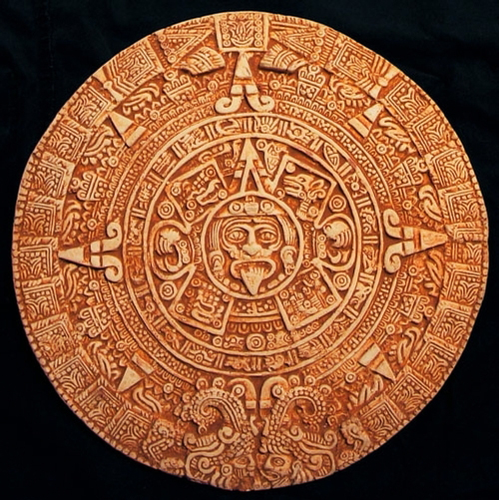
The Maya may have discovered liquid mercury (HgS+CaO) (Fuson). It would not be inconceivable that they had roasted mercuric sulfide (HgS), also called “cinnabar,” with lime to create this liquid metal. While excavating a site at San Lorenzo in Veracruz, Mexico, researcher, M. D. Coe, suggested that a piece of lodestone suspended in liquid mercury may well have been the first compass. Because liquid mercury is much denser than water, virtually any object would have floated in it. Coe theorized that a small square of magnetite (lodestone) with an indicator mark on one side (effectively and consistently pointing just east of magnetic north) could have been used by Mayan priest-astronomers as a guideline for building temples. Many observatories were oriented toward 7°30’ E, which would have been consistent with the alignment of the theorized early compass (Fuson).
The Maya calendar simultaneously followed three separate “years:” The Long Count Calendar, the Tzolkin (Divine) Calendar, and the Haab (Civil calendar). A typical Mayan date may look like this: 12.18.16.2.6, 3 Cimi 4 Zotz. 12.18.16.2.6 is the Long Count date. 3 Cimi is the Tzolkin date. 4 Zotz is the Haab date (Tøndering). Because the Maya were such great mathematicians and astronomers, they kept track of cycles of many celestial bodies, and followed each with the use of their stone calendar (See Figure 3). While their calculations were impressive, and advanced considering the limited tools and knowledge of modern astronomy, the Maya weren’t perfect. They understood that their calculations were off by approximately one day every 365-day cycle (Thompson). They made several adjustments to their dates and observatories accordingly. Because of the slight miscalculations of degrees, they rebuilt and modified their observational edifices at the end of the fifty-two-year count and especially after a double Calendar Round. When these calendars made their cycles, large-scale religious ceremonies took place, new structures were added to buildings, and stelae were dedicated as well (Fuson).
(Figure 3: 3-Count Mayan Calendar)
Mayan astronomy seems to have held a significant place in religious ceremonies for the early people of the Yucatán. Their ways were advanced and calculations near-exact. They gazed up at the heavens and tracked the journey of their sun god. They made ritual sacrifices to him so as to provide him strength to fight in the underworld so he could rise again the next day. Many have been astonished at the near-precision with which the Maya calculated of the orbital periods of celestial bodies. Their calendar and stelae have withstood the thrashing of years of weathering and are still used by some indigenous in the Yucatán. God willing, the sun will be seen to rise again in okni as the Maya people live on with the glorious legacy of their ancestors.

Bibliography

Fuson, Robert H. "The Orientation of Mayan Ceremonial Centers." Annals of the Association of American Geographers (1969): 494-511. www.jstor.org.
Thompson, J.E.S. "Maya Astronomy." Philosophical Transactions of the Royal Society of London. Series A, Mathematical and Physical Sciences, Vol. 276, No. 1257, The Place of Astronomy in the Ancient World (1974): 83-98. www.jstor.org.
Tøndering, Claus. Calendars Through the Ages. 2008. http://www.webexhibits.org/calendars/calendar-mayan.html. 23 April 2012.
Watanabe, John M. "In the World of the Sun: A Cognitive Model of Mayan Cosmology." Royal Anthropological Institute of Great Britain and Ireland (1983): 710-728. www.jstor.org.

